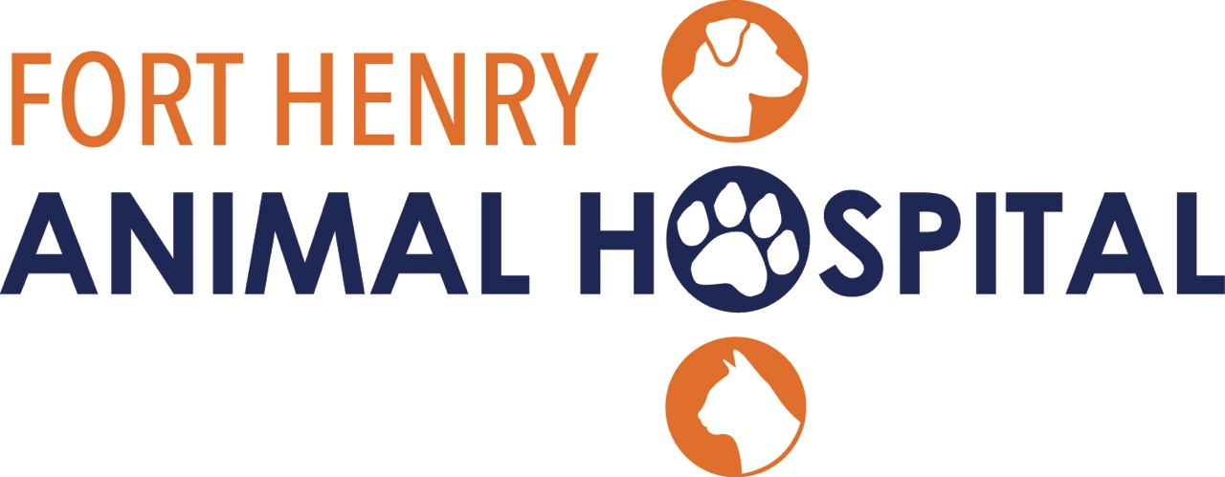

CARE TO SHARE
Refer your friends and family members!
Share your great experience at
Fort Henry Animal Hospital
with friends and family.
There’s no limit. You keep sharing, and we’ll keep caring.
With our Care to Share Program, everyone wins.
When your friends and family become a client,
they get a $5 credit and you get a $5 credit too!
Name:_____________________I was referred to
Fort Henry Animal Hospital by:____________________
3786 Fort Henry Dr. Kingsport, TN 37663
(423) 239-6711

